**DAILY ONLINE ACTIVITIES SUMMARY**

|  |  |  |  |  |  |  |  |
| --- | --- | --- | --- | --- | --- | --- | --- |
| **Date:** | **26/05/2020** | | | | **Name:** | **KHADHIJA SAFREENA** | |
| **Sem & Sec** | **4th & A sec** | | | | **USN:** | **4AL18CS037** | |
| **Online Test Summary** | | | | | | | |
| **Subject** | | **DESIGN AND ANALYSIS OF ALGORITHM** | | | | | |
| **Max. Marks** | | **30** | | **Score** | | **19** | |
| **Certification Course Summary** | | | | | | | |
| **Course** | **INTRODUCTION TO DIGITAL MARKETING.** | | | | | | |
| **Certificate Provider** | | | **Great learning** | **Duration** | | | **2.5 HOURS** |
| **Coding Challenges** | | | | | | | |
| **Problem Statement:1:Write a program in c to print all permutations of a given string using array**  **Problem Statement 2:** . **Given an array A of size N where the array elements contain values from 1 to N with duplicates, the task is to find total number of subarrays which start and end with the same element.** | | | | | | | |
| **Status: executed** | | | | | | | |
| **Uploaded the report in GitHub** | | | | **YES** | | | |
| **If yes Repository name** | | | | **[http://Shafreenasharief / lockdown-coding](http://hafreenasharief / lockdown-coding" \o "http://hafreenasharief / lockdown-coding)** | | | |
| **Uploaded the report in slack** | | | | **YES** | | | |

* **ONLINE TEST SUMMARY:**

**DESIGN AND ANALYSIS OF ALGORITHM**

**18CS42 the test was from 2nd module about divide and conquer. There are 30 questions and the dur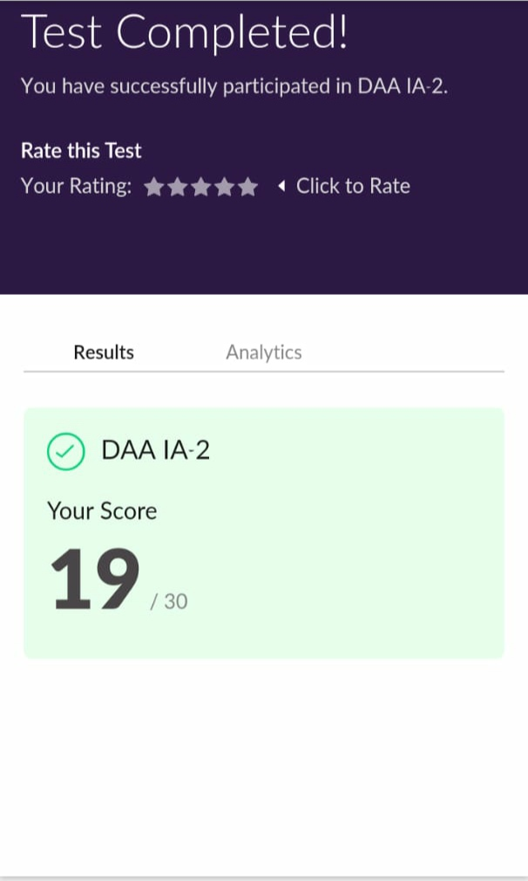ation 30 minutes.**

* **ONLINE CERTIFICATION COURSE:**
* I'm doing certification course on INTRODUCTION TO DIGITAL MARKETING on great learning.The course is secluded for 2.5 hour.Today I completed 2 module which is Explanation of new media-cont & Understanding the brand purpose.I attempted quiz which gave me a clear veiw about the topics that were thought and discussed.
* It consists of 10 modules including assessments.

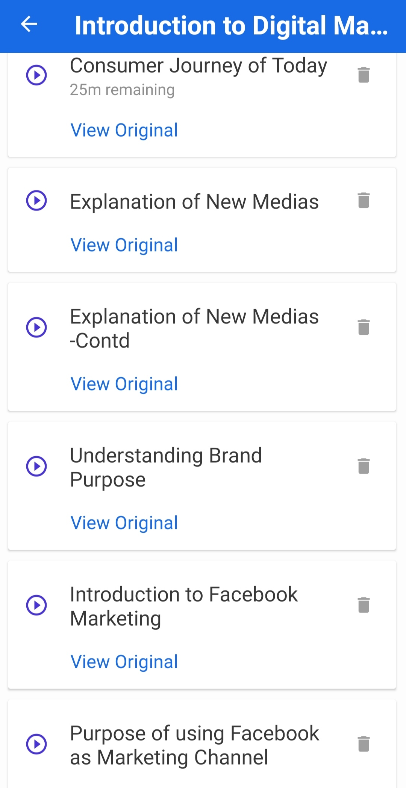

* **ONLINE CODING SUMMARY:**

**1.Write a program in c to print all permutations of a given string using array**

**2. Given an array A of size N where the array elements contain values from 1 to N with duplicates, the task is to find total number of subarrays which start and end with the s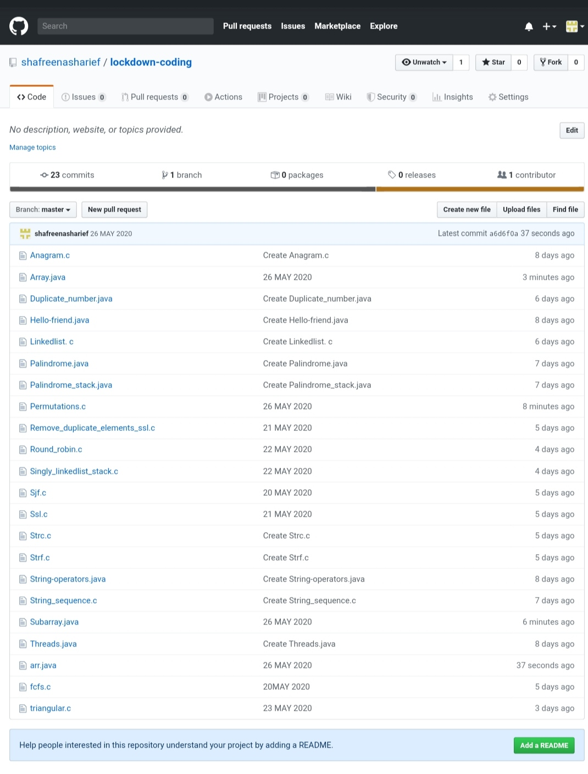ame element.**